Data Analysis Report

Medel, Andrei Kyo D.

BSCpE - 2A

MATHEDA Engineering Data Analysis

Professor: ENGR. Gyro A. Madrona

**Introduction:**

In order to enhance the understanding of the chips manufacturing market and its trends, the task of creating an exploratory data analysis of the mentioned market has been assigned.

**Purpose:**

The purpose of this report is to sort out the analysis of the cleaned dataset provided which contains detailed information about various products within the market including their respective specifications.

Such specifications include process size, Thermal Design Power, Die size, Transistors, frequency etc.

**Objectives:**

The main objectives of this report is to analyze the dataset, uncover meaningful insights, and present a summarization within this report with visualizations and recommendations.

**Key specifications:**

The following Specifications will delve into the trends of these factors for CPUs and GPUs.

1. Thermal Design Power
2. Process Sizes
3. Die Sizes
4. Transistors
5. Frequencies

Manufacturing Details

The Following Graphs will represent various details about the chips manufactured and what each specification trend will cover.

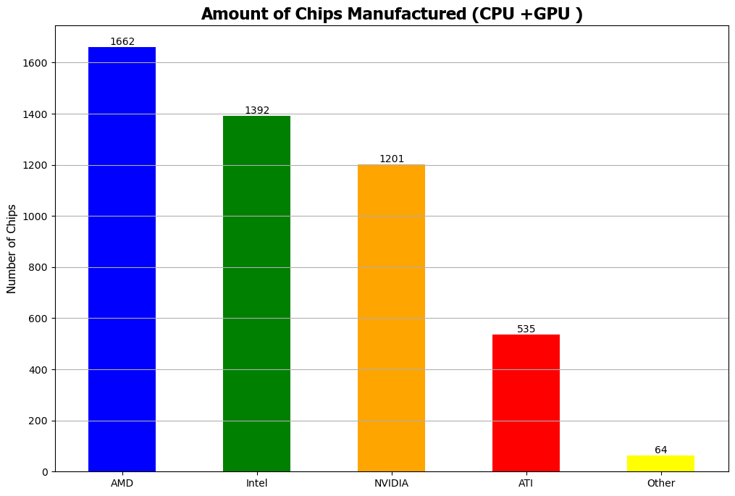

The graph above shows the number of Chips manufactured per Vendor for both CPUs and GPUs.

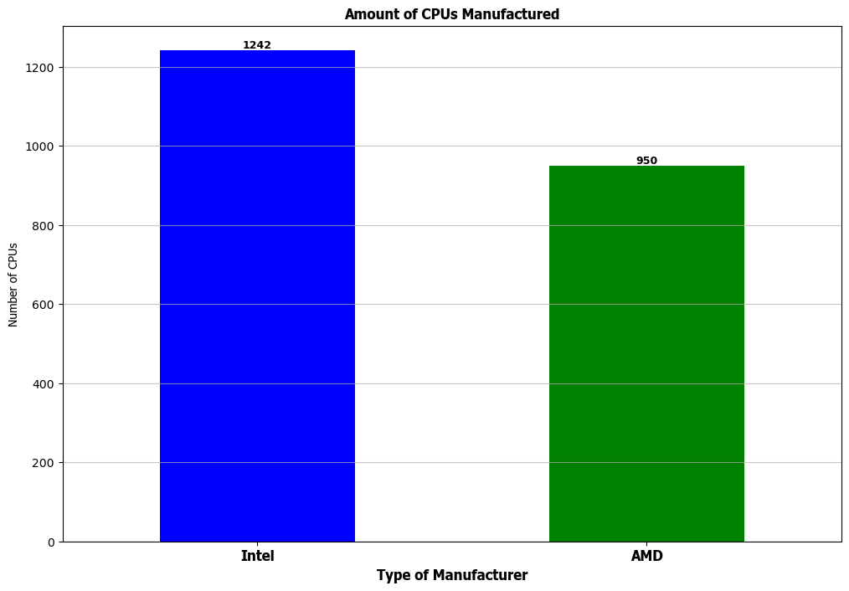This Graph showcases the number of CPUs manufactured.

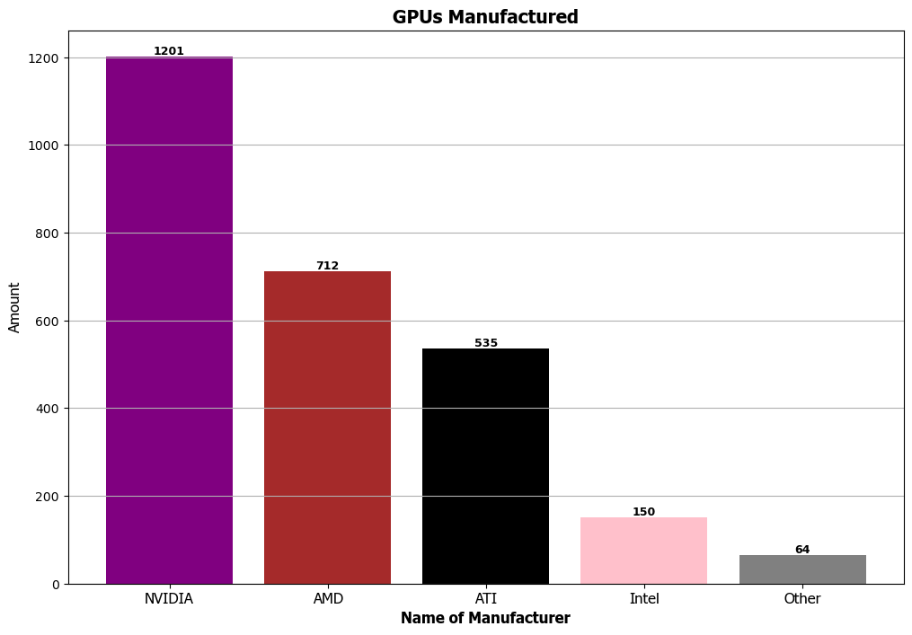

This Graph displays the Number of GPUs that have been manufactured within the dataset provided.

Thermal Design Power

Thermal Design Power or TDP for short, refers to CPU power consumption and the amount of heat that it can generate that the respective cooling system can dissipate during normal operation at a non-turbo clock rate.

The following Graphs will contain the lowest and Highest TDP for CPUs and GPUs respectively.

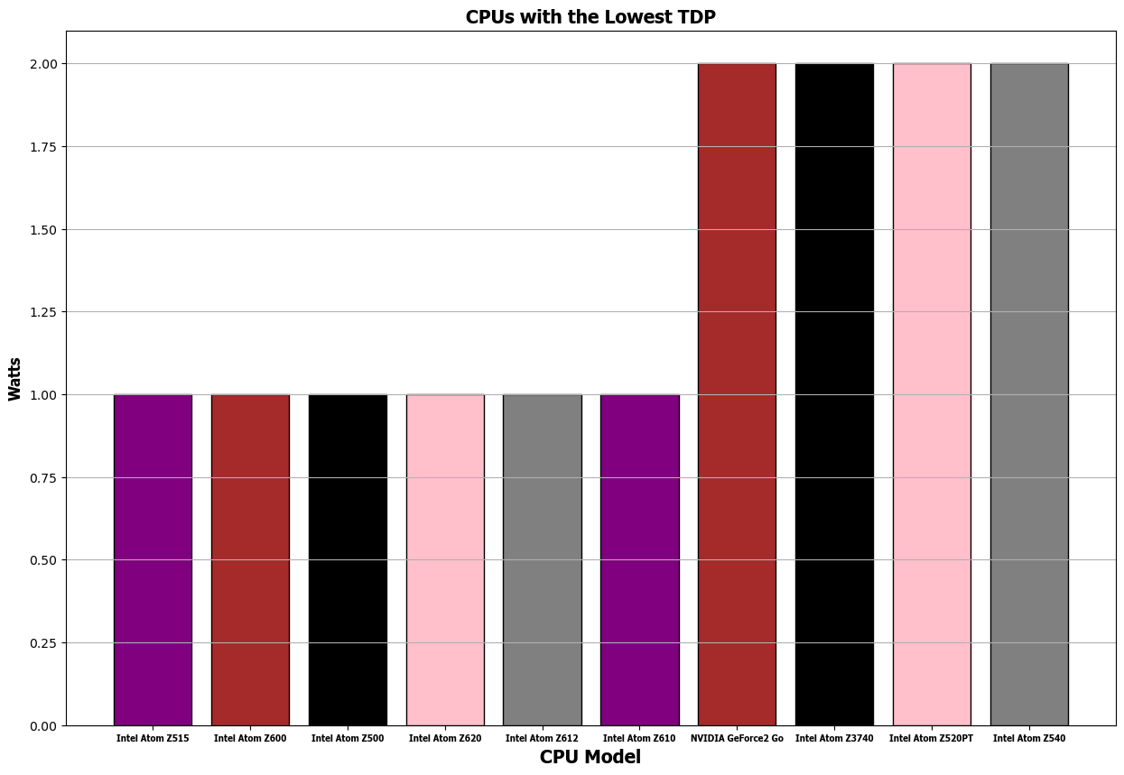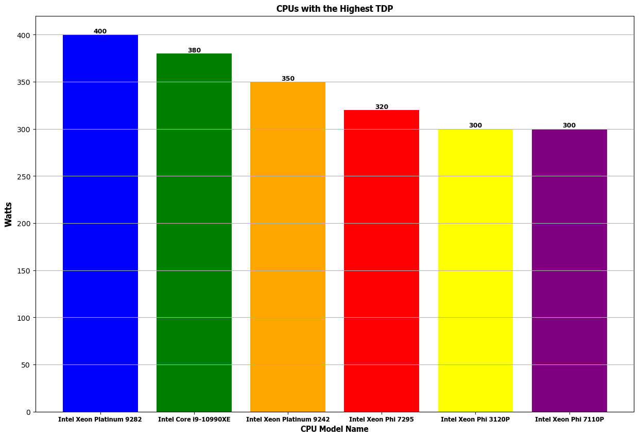

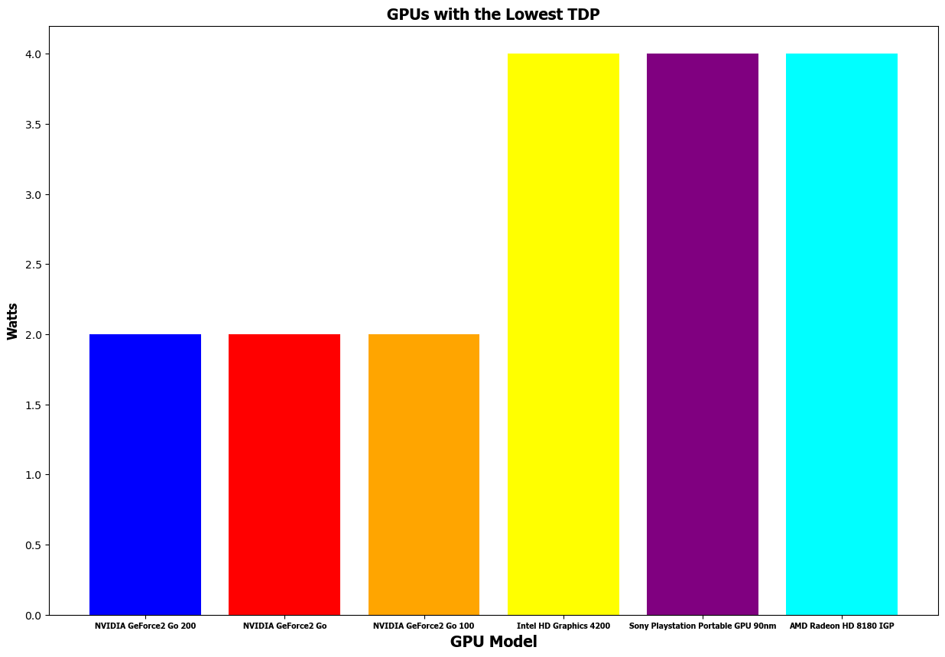

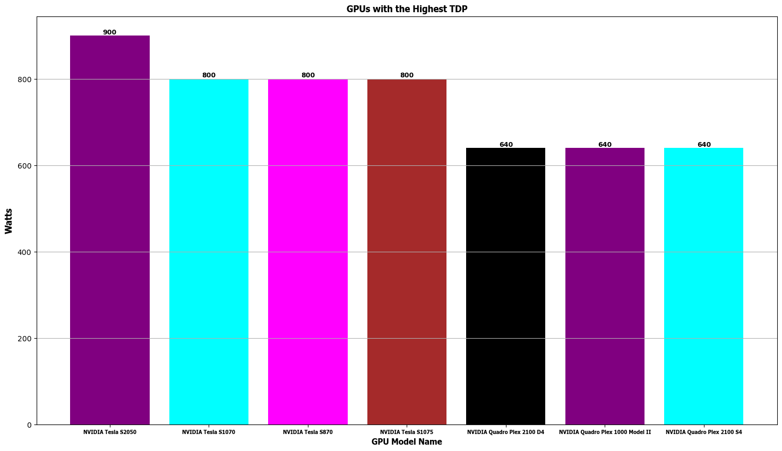

Specification Trends

This segment will cover the trends over time for the various specifications within the CPUs and GPUs provided.

CPU Trends

